**State Transition Diagram Testing for Complete project**

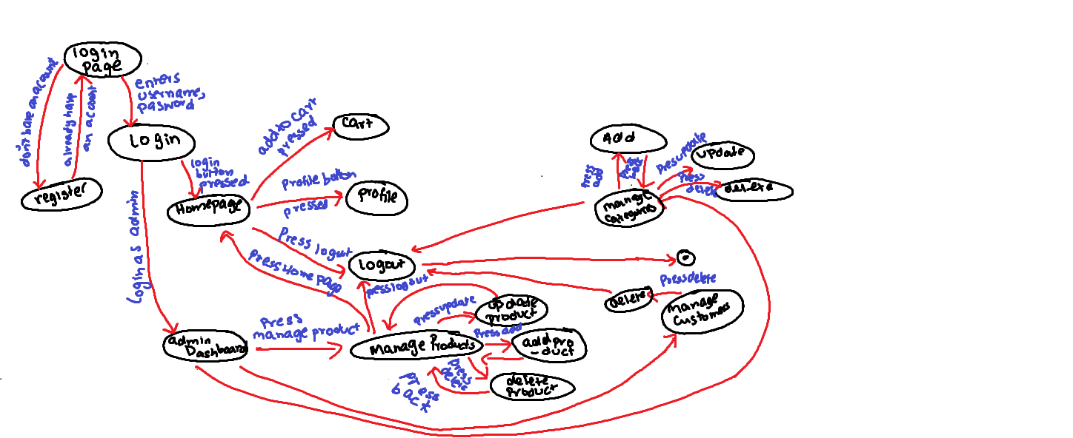

**States:**

State 1 : User is on login page

State 2: User is on Homepage

State 3 : register

State 4: User is on Cart

State 5: User is on profile

State 6: log out

State 7: admin is on Dashboard

State 8: User is on manage product

State 9: User is on add product

State 10: User is on update product

State 11: User is on Delete product

State 12: User is on Manage categories

State 13: User is on update category

State 14: User is on delete category

State 15: User is on add category

State 16: User is on Manage customers

State 17: User is on add customers

State 18: User is on Delete customer

State 19: User is on update customer

**Transitions:**

T1: Transition from S1 to S2

T2: Transition from S1 to S3

T3: Transition from S3 to S1

T4: Transition from S2 to S4

T5: Transition from S2 to S7

T6: Transition from S7 to S8

T7: Transition from S8 to S9

T8: Transition from S8 to S10

T9: Transition from S8 to S11

T10: Transition from S7 to S12

T12: Transition from S12 to S13

T13: Transition from S12 to S14

T14: Transition from S12 to S15

T15: Transition from S7 to S16

T18: Transition from S16 to S17

T19: Transition from S16 to S18

T20: Transition from S16 to S6

**Events:**

E1: User logs in

E2: User don’t have an account

E3: User clicks profile

E4: User clicks log out

E5: User clicks Homepage

E6: User clicks logout

E7: User clicks cart

E8: logs in as an admin

E9: User clicks manage product

E10: User clicks update product

E11: User clicks delete product

E12: User clicks add product

E13: User clicks manage categories

E14: User clicks add categories

E15: User clicks update categories

E16: User clicks delete categories

E17: User clicks manage customers

E18: User clicks add customers

E19: User clicks delete customers

E20: User clicks update customers

**STATE DIAGRAM TEST CASES**

| **Current State** | **Event** | **Action** | **Next State** |
| --- | --- | --- | --- |
| S1 | E1 | - | S2 |
| S1 | E2 | - | S3 |
| S2 | E3 | - | S5 |
| S2 | E4 | - | S5 |
| S2 | E5 | - | S6 |
| S2 | E7 | - | S4 |
| S2 | E8 | - | S7 |
| S7 | E9 | - | S8 |
| S8 | E10 | - | S9 |
| S9 | E11 | - | S10 |
| S9 | E12 | - | S11 |
| S7 | E13 | - | S12 |
| S12 | E14 | - | S13 |
| S12 | E15 | - | S14 |
| S12 | E16 | - | S15 |
| S7 | E17 | - | S16 |
| S16 | E18 | - | S17 |
| S16 | E19 | - | S18 |
| S16 | E20 | - | S19 |